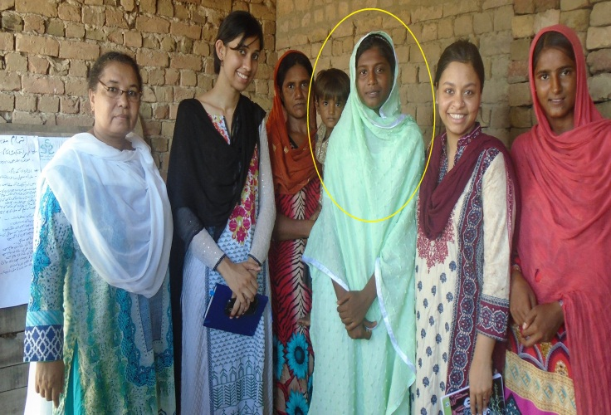
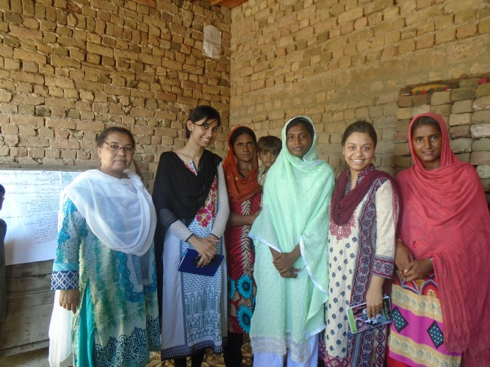
Success Story of Mahnaz
Mahnaz is a 13 years old girl, she lives a little and backward village of Jan Muhammad Unar, of UC Jamal Shah Taluka Daur, Project Area of “Community Action to Curb Violence against women”
She is student of six class belongs to a poor village when lack of education specially for females in this village no any concept of women rights gender justice and rights of inheritance as well human rights. Man is dealing with his female like an animal; according to all male of this village females are not able to do anything independently so many issues in this village like:
- Child marriage
- Force marriage
- Wata Satta Marriage
- Marriage on money
Mahnaz Also is a part of this violence, Mahnaz want to get education but her family was want to her marriage, she was not happy from marriage, she was worried about her future and she is praying from God for Miracle.
One Day Gender Justice Program team went to her village for the formation of village group in the project of “Community action to curb violence against women and girls” that time mahnaz also just participate this meeting and agrees to join this group as member but she can’t share any single word regarding her issue.
When mobilization meeting was held in same village in this meeting project objective supporting mechanism and organization’s history was briefly shared to participants and all women discussed their issues and issues are happened in this village in common.
After the completion of the meeting when all women leave the place Innocent Girl Shahnaz came to Ms. Bushra (Social Organizer of Gender Justice Program – SSSF) and discussed her issue in details. Strategically a meeting was called in this group on next day and agenda was planned that we discussed topic of early child marriage.
On next day during the meeting in detailed discussion was held and participants highlights issues.
Ms. Bushra described that by the approved law of Sindh Government it is a punishable crime that any parent made marriage of his child in under the age of 18, and society this person was not seen in good manner,
During the monitoring visit of NCA, Mahnaz attended meeting and says that our parents are agree to postpone my marriage after the agreed age and after my education. And Miss Mahnaz says thank you to Delegation of NCA, South Asia Partnership Pakistan and Shah Sachal Sami Foundation.

